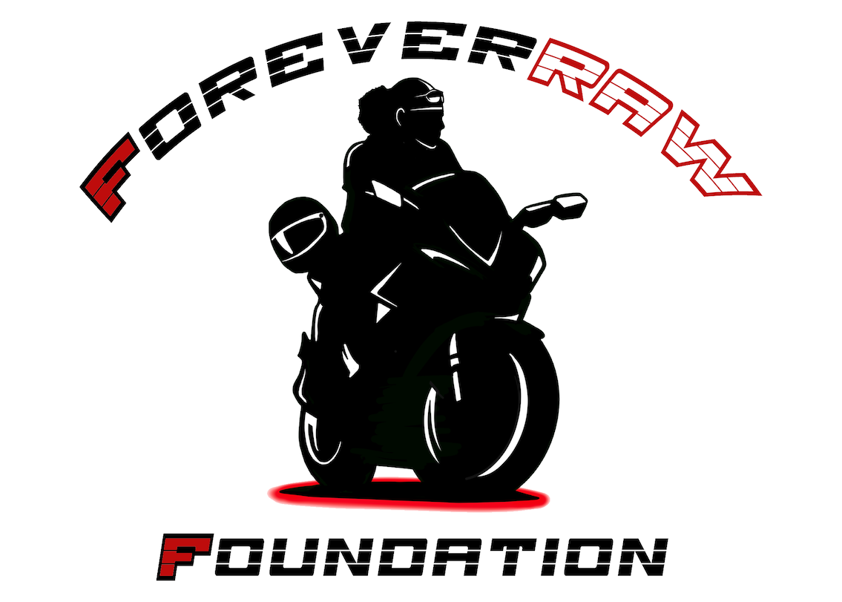
#ForeverRAW Foundation, Inc.
P.O. Box 645
Bear, Delaware 19701
Foundation Scholarship
(Application Deadline: August 28, 2023)
info@ForeverRAWfoundation.com

The #ForeverRAW Foundation will award merit scholarships annually to eligible students meeting the Foundation standard having followed all guidelines. This scholarship is awarded to any eligible college accepted student regardless of major. Disbursement of scholarship award requires:
- A Copy of College Acceptance Letter
- All required forms to be completed with current and active information and returned by date given including Foundation Disbursement Request Form Completed
- An Essay written exclusively by the student no professional essays accepted
Essay must include exactly what your need is and should encompass: What type of character you have? What personally has gotten you to this point today? What passions do you have? How you think? How do you feel about the world? How do you feel about others?
- Three Recommendations
2 from persons (not related) who know you well and can attest to your
character
1 from your Pastor who must attest to your character and involvement in
Church

The award will be held in trust for six months after which if a criterion has not been met prohibiting award to be disbursed to college or information given is not complete and communication cannot be made the award will be returned to the Foundation Scholarship Fund and award will be forfeited. However, it does not disqualify the student from reapplying.

This scholarship was birthed out of the memory of Rick Anthony Williams and the legacy he left in his character. Rick attended a church-based youth retreat annually and was well known at the retreat by fellow retreaters for his jovial spirit. He was known to the Leadership for being active and not just a spectator. He was engaged in what was going on and did not have to be made to do what was needed or required. Rick would step up with humility not loud or boastful. Rick was not perfect but knew to be respectful, generous, obedient and a helper to all in charge. Rick loved the Lord and was not ashamed to admit it. His favorite article of clothing next to Adidas gear was his “Jesus is my Homeboy” t-shirt.

On a personal note, just to give an example of Rick’s assistance: The bus for the Retreat broke down one year at the bottom of the hill Rick and his two brothers by request from the Retreat Staff hauled all other Retreaters luggage on their rolling luggage up the hill, making multiple trips that the retreaters could be safe and receive their luggage. Another example of Rick’s character was of a woman who saw all the social media posts of Rick having been killed and contacted our family. She said she was broken down on the side of the road when Rick stopped to help. He bought a battery for her car, took her to his home where he installed an alternator. After her telling him she had no money. Rick told her he didn’t need any money he just wanted to get her off the side of the road because it was unsafe. She let us know she was alone and pregnant. He used his gifts for good and to the glory of God, not for greed and notoriety.

Rick unfortunately was killed by a drunk driver on June 24, 2017, about three blocks away from his home; his mother, father, brothers, and sister formed the #ForeverRAW Foundation to honor Rick and keep his memory alive. Rick was a certified degreed mechanic having attended OTC (Ohio Technical College) one of the top diesel technology colleges at that time. He worked as a mechanic for Ford Motor Company after graduation. But most importantly Rick was a giver who would lend a hand to almost anyone. He loved his family and greatly respected his mother. May the recipient of this award be blessed by the giving of the #ForeverRAW Foundation and Rick’s Legacy.

*IMPORTANT: Please write legibly and fill out information completely unless the application may become void at the discretion of the Board.

Recipient must be independent of Foundation, individuals, institutions, or corporations involved in funding.

The Foundation Board or Executive Directors will determine final approval and selection of recipient.

The criteria/characteristics displayed should come from a natural, honest nature and not just words written to acquire scholarship.

#ForeverRAW Foundation Inc.

Application Form
FORM MUST BE COMPLETELY AND LEGIBLY FILLED OUT

PERSONAL DATA

NAME: ________________________________________________________________________
LAST FIRST M.I.

ADDRESS: ________________________________________________________________________
STREET CITY STATE ZIP

EMAIL: ________________________________________________________________________

PHONE: __________________________________ HOME#: _____________________

NAME/ADDRESS OF SCHOOL: _________________________________________________

_________________________________________________

GRADE STATUS: _________________________________

CAREER ASPIRATIONS:

______________________________________________________________________________

FAMILY DATA

MOTHER: ________________________________________________________________________
LAST FIRST M.I.

FATHER: ________________________________________________________________________
LAST FIRST M.I.

NUMBER OF SIBLINGS: OLDER _________ YOUNGER ________

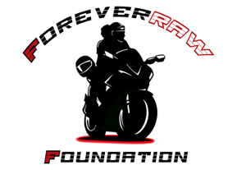
#ForeverRAW Foundation Scholarship
Disbursement Form

A. Background

NAME:

__________________________________________________________________
LAST FIRST MIDDLE

HOME ADDRESS:

__________________________________________________________________
STREET APT. #

__________________________________________________________________
CITY STATE ZIP

TELEPHONE: (___) ________________________ E-MAIL: __________________

B. School Information

College Attending: __________________________________________________________________

School Address: __________________________________________________________________
STREET
__________________________________________________________________
CITY STATE ZIP

Telephone: (___) __________________________ E-MAIL: __________________

Contact: _________________________________ E-MAIL: __________________

Major: _________________________________ Anticipated Graduation Year ___

Mailing Address for Scholarship Check: school address/school specified option

School Specified Option: __________________________________________________________________

__________________________________________________________________

__________________________________________________________________

Page 1 of 2
#ForeverRAW Foundation Scholarship
Disbursement Request

C. Include the following with this request

1. Official Transcript

For Entering Freshman – Attach an official high school transcript in a sealed envelope, stamped and signed by an officer of the school

For Returning Student – Attach an official college transcript in a sealed envelope, stamped and signed by an officer of the school.

2. Proof of Enrollment

Attach a copy of your class registration for the upcoming semester.

D. Certification

I verify that the information provided in this disbursement request form is complete and accurate to the best of my knowledge. I understand falsification of any information will cause disqualification from this scholarship.

Student Signature: _______________________________ Date: _____

Student ID #: _______________________________

Upon completion of the Scholarship Disbursement Request, sign and return immediately to:

ForeverRAW Foundation Inc.
Attn: Scholarship Committee
P. O. Box 645
Bear, Delaware 19701

You may also email documents to: info@ForeverRAWfoundation.com

Page 2 of 2

